SPONSORSHIP OPPORTUNITIES FOR BUSINESS PARTNERS

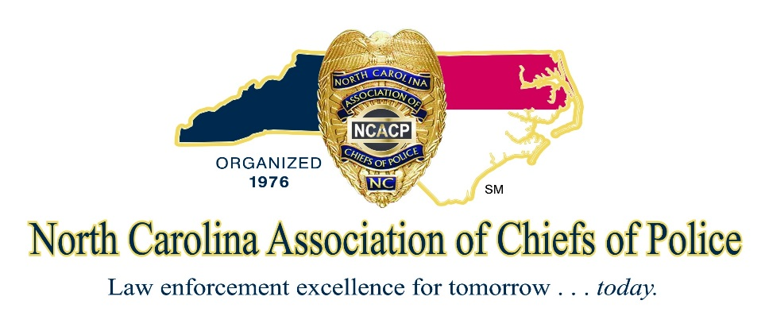

DOUBLE PLATINUM LEVEL:
$15,000 Annual Conference Sponsor/Corporate Captain/Presentation/Banquet Table/NC Police Chief Magazine/Conference Banquet Sponsor

- Complimentary advertisement in the North Carolina Police Chief Magazine
- Sole Sponsor of Conference Banquet (Presentation to those in attendance)
- Presentation Time allotted to address annual conference attendees during training session
- Premiere annual conference booth (Complimentary)
- Annual conference reserved banquet table
- Logo and link from the NCACP Website
- Logo on Jumbo Trons at the NCACP annual conference (Two 20' X 30' screens)
- Logo & recognition in the NCACP annual conference program
- Eight (8) attendees for the annual conference
- Associate Memberships for two in the NCACP (Complimentary)
- Corporate Highlight to NC Chiefs in the NCACP Chiefs Alert Email Update
- Complimentary advertisement in the NC Chiefs Buyer's Guide Website
- Invitations to regional meetings (The only vendors invited are Corporate Captains)
- Recognition at special events.

PLATINUM LEVEL:
$10,000 Annual Conference Sponsor/Corporate Captain/Presentation/Banquet Table/NC Police Chief Magazine/President’s Reception or Host Chief’s Reception Sponsor

- Complimentary advertisement in the North Carolina Police Chief Magazine
- Sponsor of President’s Reception or Host Chief’s Reception (Presentation to those in attendance)
- Presentation Time allotted to address annual conference attendees during training session
- Premiere annual conference booth (Complimentary)
- Annual conference reserved banquet table
- Logo and link from the NCACP Website
- Logo on Jumbo Trons at the NCACP annual conference (Two 20' X 30' screens)
- Logo & recognition in the NCACP annual conference program
- Eight (8) attendees for the annual conference
- Associate Memberships for two in the NCACP (Complimentary)
- Corporate Highlight to NC Chiefs in the NCACP Chiefs Alert Email Update
- Complimentary advertisement in the NC Chiefs Buyer's Guide Website
- Invitations to regional meetings (The only vendors invited are Corporate Captains)
- Recognition at special events.

RED DIAMOND LEVEL:
$5,000 Annual Conference Sponsor/Corporate Captain/Presentation/Banquet Table/NC Police Chief Magazine

- Complimentary advertisement in the North Carolina Police Chief Magazine
- Presentation Time allotted to address annual conference attendees
- Premiere annual conference booth (Complimentary)
- Annual conference reserved banquet table
- Logo and link from the NCACP Website
- Logo on Jumbo Trons at the NCACP annual conference (Two 20' X 30' screens)
- Logo & recognition in the NCACP annual conference program
- Six (6) attendees for the annual conference
- Associate Memberships for two in the NCACP (Complimentary)
- Corporate Highlight to NC Chiefs in the NCACP Chiefs Alert Email Update
- Complimentary advertisement in the NC Chiefs Buyer's Guide Website
- Invitations to regional meetings (The only vendors invited are Corporate Captains)
- Recognition at special events.

DIAMOND LEVEL:
$3,000 Annual Conference Sponsor/Corporate Captain/Presentation

- Presentation Time allotted to address annual conference attendees
- Premiere annual conference booth (Complimentary)
- Logo and link from the NCACP Website
- Logo on Jumbo Trons at the NCACP annual conference (Two 20' X 30' screens)
- Logo & recognition in the NCACP annual conference program
- Four (4) attendees for the annual conference
- Associate Memberships for two in the NCACP (Complimentary)
- Corporate Highlight to NC Chiefs in the NCACP Chiefs Alert Email Update
- Complimentary advertisement in the NC Chiefs Buyer's Guide Website
- Invitations to regional meetings (The only vendors invited are Corporate Captains)
- Recognition at special events.

EMERALD LEVEL:
$2,000 Annual Conference Sponsor/Corporate Captain

- Premiere annual conference booth (Complimentary)
- Logo and link from the NCACP Website
- Logo on Jumbo Trons at the NCACP annual conference (Two 20' X 30' screens)
- Logo & recognition in the NCACP annual conference program
- Four (4) attendees for the annual conference
- Associate Memberships for two in the NCACP (Complimentary)
- Corporate Highlight to NC Chiefs in the NCACP Chiefs Alert Email Update
- Complimentary advertisement in the NC Chiefs Buyer's Guide Website
- Invitations to regional meetings (The only vendors invited are Corporate Captains)
- Recognition at special events.

RUBY LEVEL:
$1,000 Annual Conference Sponsor
- Logo on Jumbo Trons at the NCACP annual conference (Two 20' X 30' screens)
- Logo & recognition in the NCACP annual conference program
- Associate Memberships for one in the NCACP (Complimentary)
- Complimentary advertisement in the NC Chiefs Buyer's Guide Website
- Recognition at special events.

SAPPHIRE LEVEL:
$500 Annual Conference Sponsor

- Logo on Jumbo Trons at the NCACP annual conference (Two 20' X 30' screens)
- Logo & recognition in the NCACP annual conference program
- Associate Memberships for one in the NCACP (Complimentary)

ONYX:
$250 Annual Conference Sponsor

- Logo on Jumbo Trons at the NCACP annual conference (Two 20' X 30' screens)
- Logo & recognition in the NCACP annual conference program

$500 Annual Conference Sponsor/Banquet Table

- Annual Conference reserved banquet table
- Recognition in the NCACP annual conference program

